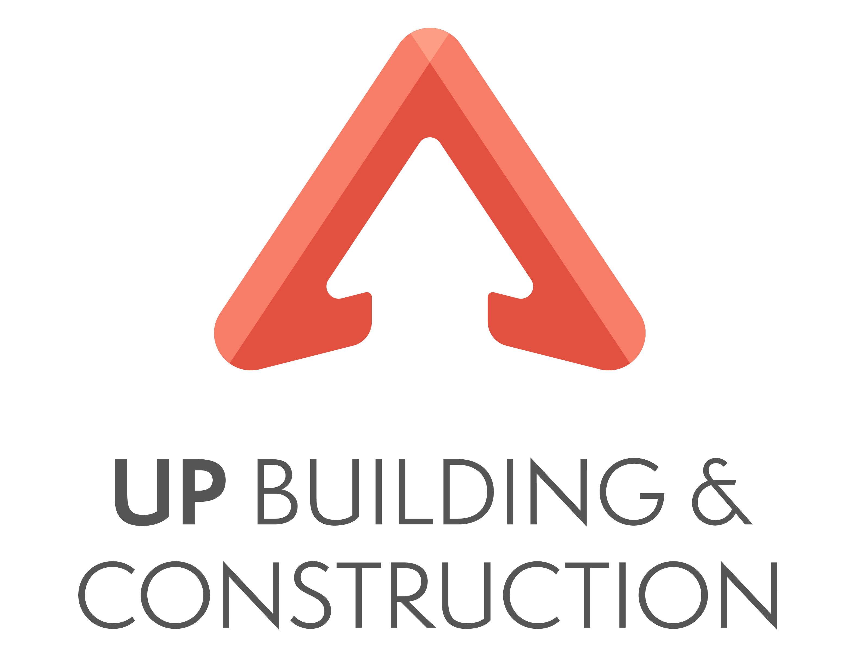 UP Building and Construction Pty Ltd

“Building dreams from the ground UP”

ABN 123 456 789

**Plant and Equipment – Quality Systems**

Contents

**Plant and Equipment – Quality Systems** 1

1. Context 2

2. Hiring Plant and Equipment 2

3. Recording Plant and Equipment Hire 2

4. Plant and Hire Safety Considerations 2

5. Temporary Services and Accommodation Requirements 3

1. Context

**Plant** refers to the larger mechanical pieces of machinery which may be used on-site, such as a tower lift or compressor.

The term **equipment** describes the smaller non-mechanical tools such as ladders and wheelbarrows.

**Temporary services** and **site accommodation requirements** need to be determined as part of the plant and equipment requirements.

2. Hiring Plant and Equipment

All plant and equipment hire should be coordinated by the Site Supervisor and factored into the costs of the project. All plant and equipment must meet Australian Standards.

Where possible, all plant and equipment hire should be organised from National Plant and Equipment Hire. They have locations across Australia and offer UP Building and Construction agreed rates for all work.

Ensure that you provide the work site location and job number when placing all hire requests to ensure this is billed correctly.

3. Recording Plant and Equipment Hire

Plant and equipment requirements are usually determined at the estimating stage of the project and/or when the project schedule is prepared. These requirements can also be determined when the sub-contractors' groups are organised or when the type of work is planned.

The usual procedure for hiring single equipment items such as jackhammers is to phone around the local hire companies for quotes. In some cases, a preferred supplier may be used.

Plant hire is often done in the same way by ringing around. Alternatively, this can be part of the quoting process and the price for plant includes the operator. Sometimes the price quoted involves the additional cost of getting the plant on and off the site. For example, it can cost $400 to bring a bobcat on-site and another $400 to take it from the site.

All deliveries to site are recorded in the supervisors site diary. Equipment is checked for faults and good working order. Any faults found are to be reported to management immediately.

4. Plant and Hire Safety Considerations

It is the responsibility of UP Building and Construction to provide plant and equipment for use by designated employees and contractors (workers) as a part of their working environment and that it is safe and fit for purpose.

Plant and equipment in this context include (but is not limited to) the following:

* Tools
* Machinery
* Computers
* Tablets
* Phones

Throughout the duration of the day, all workers and contractors who are working with or operating plant equipment must comply with relevant safety measures, policies, and regulations.

It is the responsibility of UP to ensure:

* Plant and equipment manufacturer and safety standards are met
* Plant and equipment are insured and registered (as appropriate)
* Servicing of plant and equipment is in accordance with the manufacturer’s instructions, as well as required scheduled/daily safety checks
* Damaged plant and equipment requiring repair will be assessed to determine the appropriate action, including replacement if necessary
* A consultative approach is adopted to ensure risks associated with plant and equipment, whether owned, leased or hired, are eliminated or reduced as far as practicable, and injuries to workers, contractors and visitors are minimised.

It is the responsibility of the worker/contractor to ensure their own safety and that of others. In order to achieve this workers/contractor must:

* Not operate any plant or equipment unless they have been authorised and/or qualified and licensed to do so
* Advise Management immediately if for any reason your licence/ticket is suspended or cancelled
* Provide a copy of relevant licences to the Company each time it is renewed
* Ensure all plant and equipment is kept cleaned and maintained
* Not smoke or be under the influence of drugs or alcohol or while impaired by prescribed medication, illness and/or injury whilst using plant or equipment
* Immediately notify the Company of any medical conditions, or other restriction that may affect their ability to operate plant or equipment
* Complete any required inspections before use to ensure it is safe to do so
* Report any faults immediately to the Manager and stop use immediately until safe operation of the plant or equipment has been repaired
* Report accidents in accordance with the Incident and Accident Reporting Procedure and ensure the Management have been advised immediately
* Ensure they understand and are aware of any warning lights that could indicate an area of concern with the plant or equipment
* Notify the Manager damages and/or defects for repair or maintenance to be arranged
* Ensure a seat belt is worn at all times when operating appropriate plant or equipment where a seatbelt is provided.

Should an accident or incident arise on site, it is essential the worker or contractor uses the company accidents and injuries template.

5. Temporary Services and Accommodation Requirements

Councils and work health and safety requirements make it a condition of the building contract that the following temporary services are supplied from the start of the building process:

* **Temporary electrical pole** or power box built into its permanent position. If a slab is being poured on the ground, the power is brought on-site and the power board is put into its permanent place. Sometimes the location of the existing service will determine this. The set back distance and overhead or underground supply need to be considered
* **Chemical toilet**, which in certain circumstances needs to be permanently plumbed
* **Waste bin**
* **Temporary fencing** around the site so that the public does not have access
* **Water tapping**to supply water to the site. This may be a short tapping (on the same side of the street) or a long tapping which requires piping under the road (if supply is on the other side of the street)
* **Seepage barriers** (in some cases) across the front of the site to stop water and soil running onto the footpath
* **'Tiger strips'** if work is to take place close to overhead powerlines
* **Barricade** to meet the local municipal by-laws. If the site cut is over one metre, a barricade is erected to prevent public access. If the site cut is less than one metre, a temporary fence is erected.

If more than 10 workers are to be employed at any one time, the work health and safety requirements are much more stringent in relation to amenities and facilities.

The nature of the project and the features of the construction site determine what temporary services and site accommodation is actually needed. Generally, temporary services and site accommodation have been built into the quote, however, a site supervisor must be aware of these points. Once temporary services and site accommodation requirements are determined, they will be documented in the project schedule as part of the resources required.

Construction sites will generally require office facilities to provide accommodation for site managers, provide space for meetings and to provide storage for site documentation. Site offices are often described as ‘site huts’ even if they are large and well fitted out.